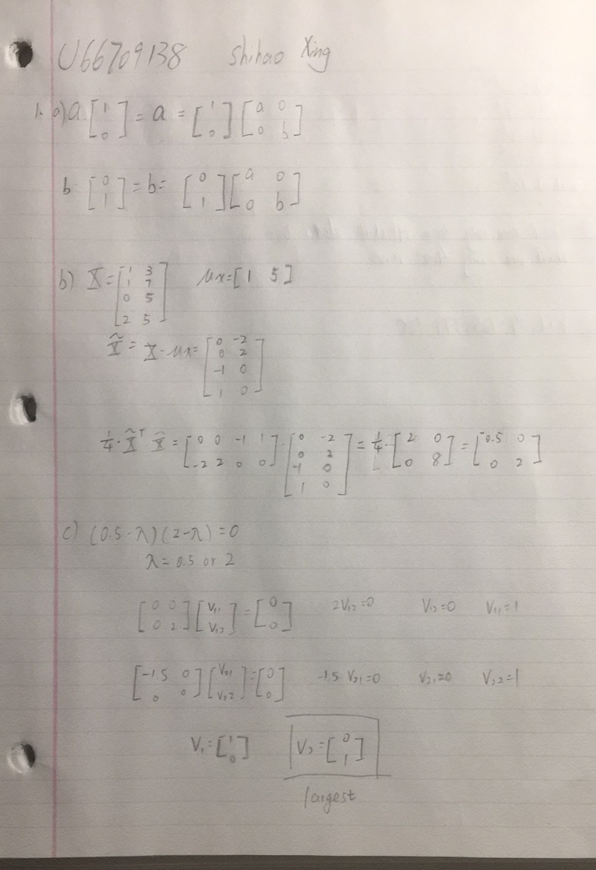

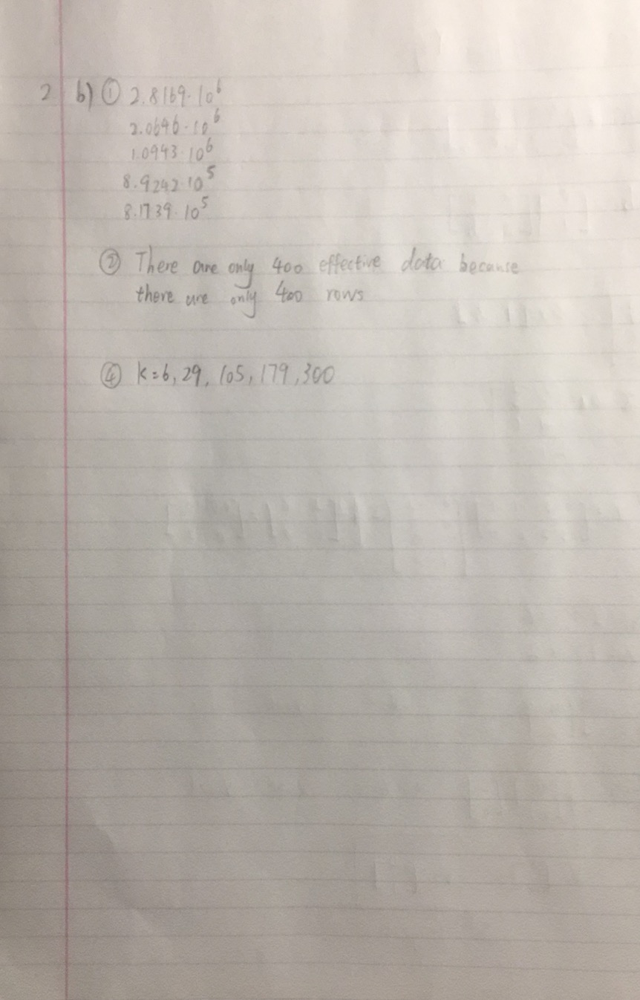

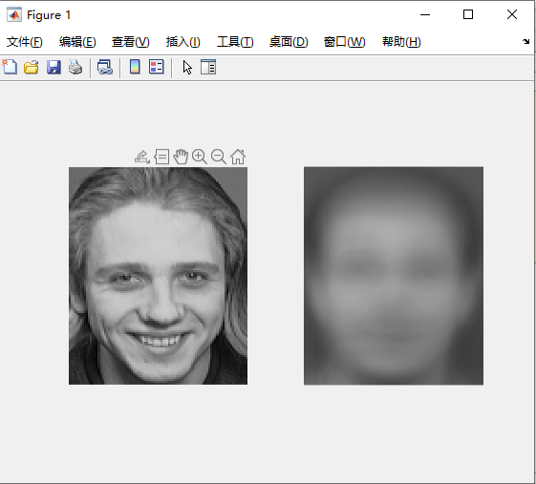

It is a smooth shapeless “blob”.

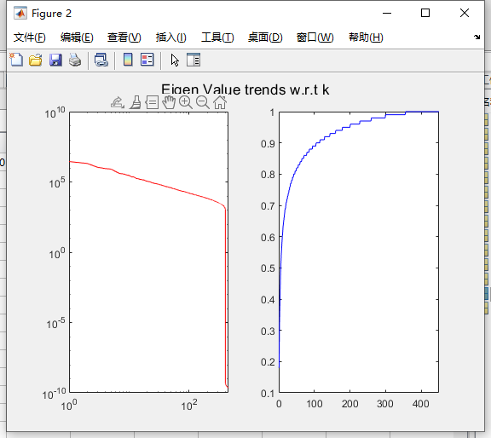

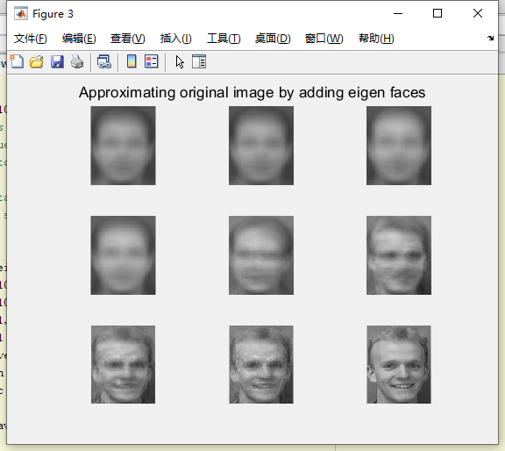

Picture (1,1): k = mean

Picture (1,2): k = 1;

Picture (1,3): k = 2;

Picture (2,1): k = 6;

Picture (2,2): k = 29;

Picture (2,3): k = 105;

Picture (3,1): k = 179;

Picture (3,2): k = 300;

Picture (3,3): origin picture